- 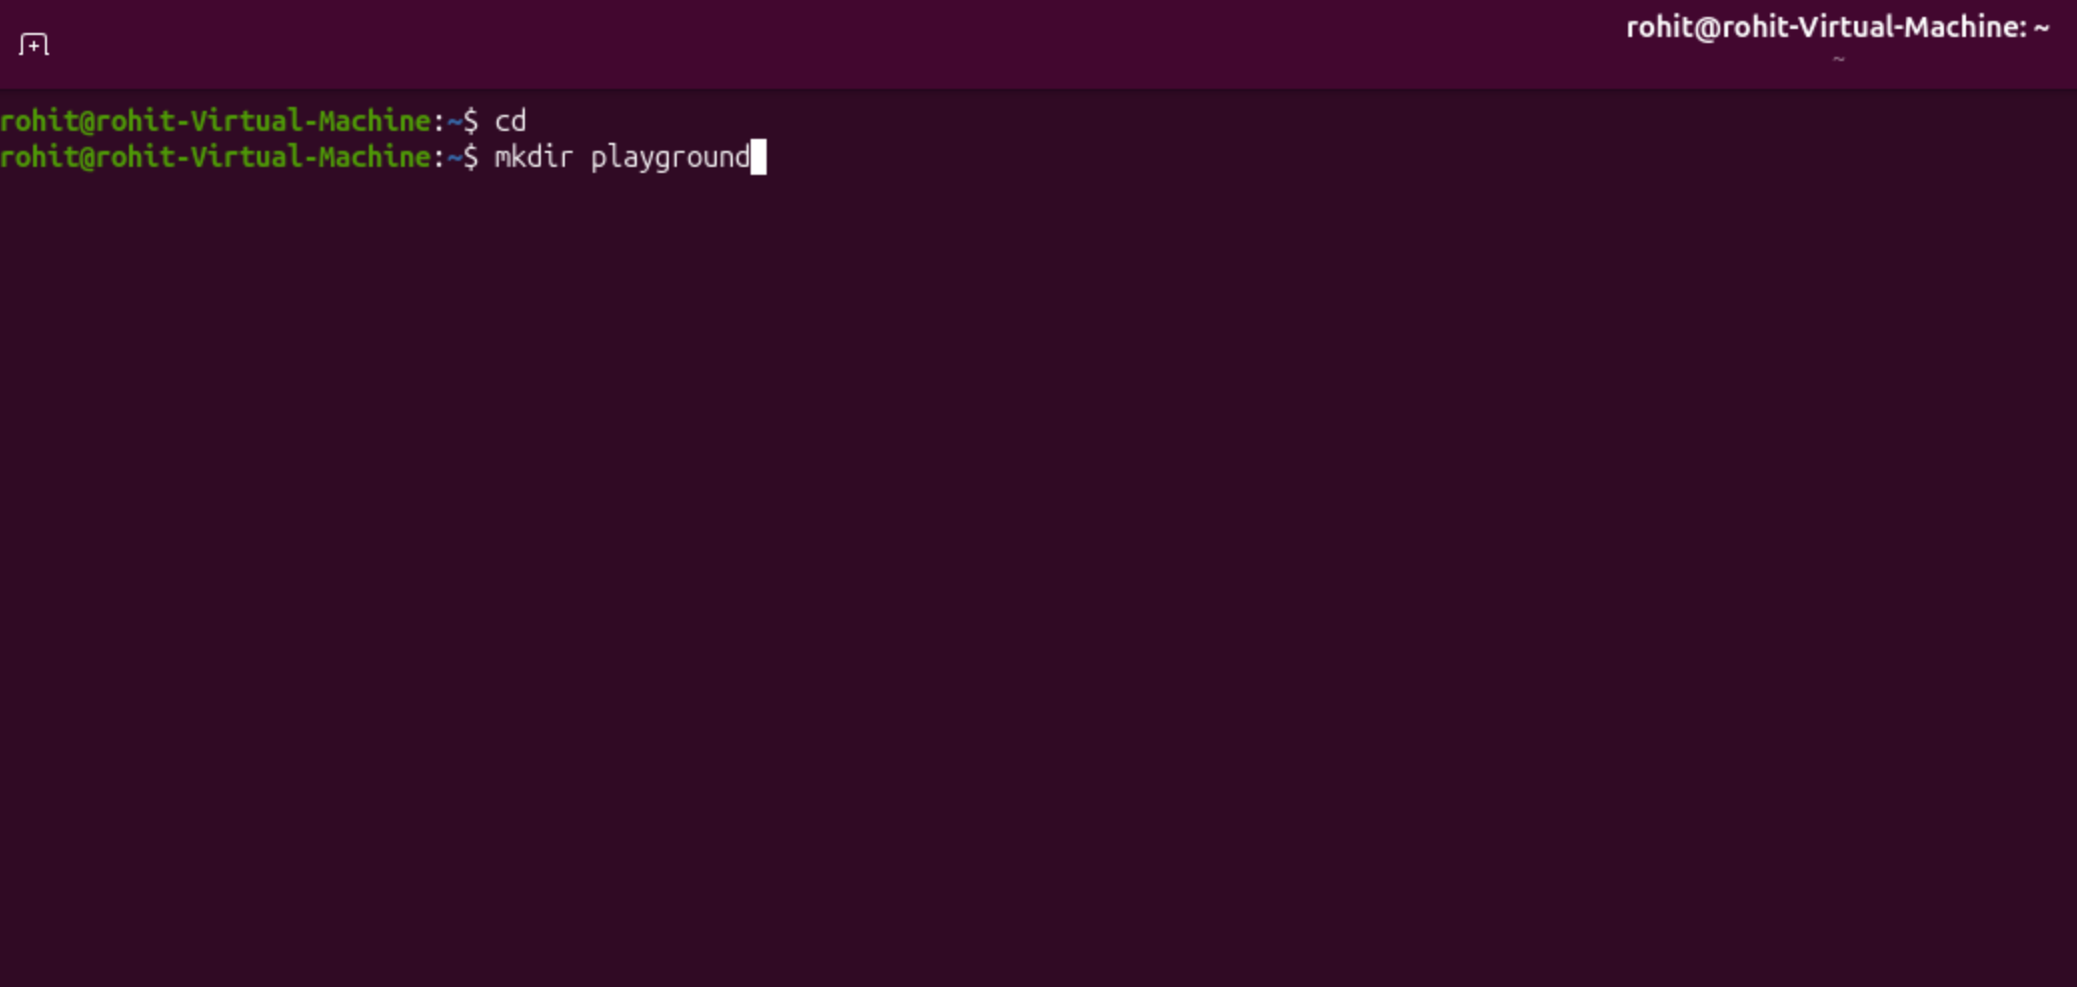
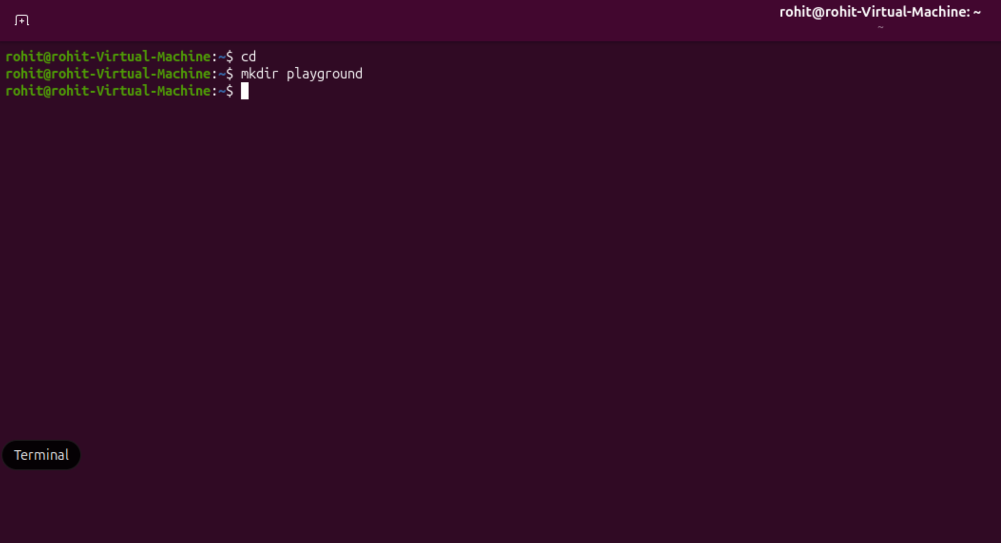

cd and mkdir playground did not produce any output on screen; it did however create a folder called playground.

- 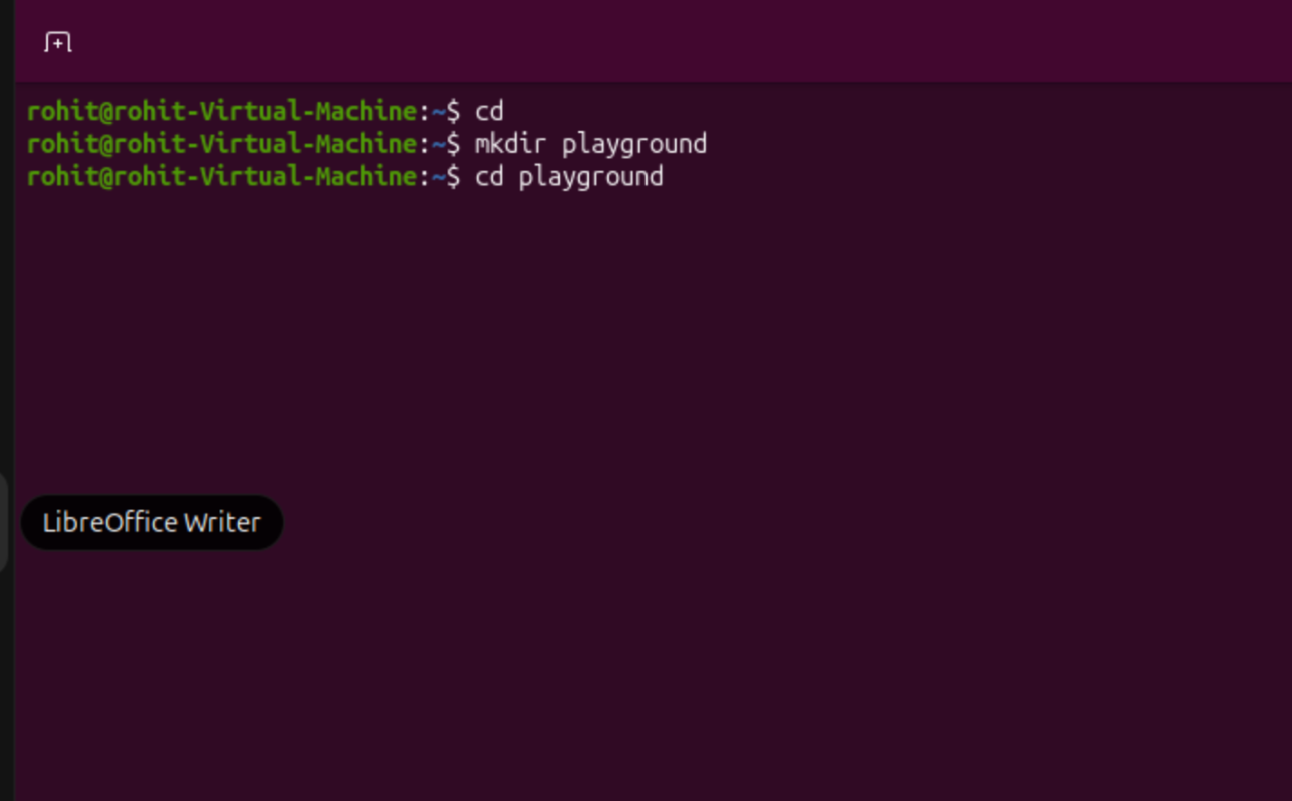
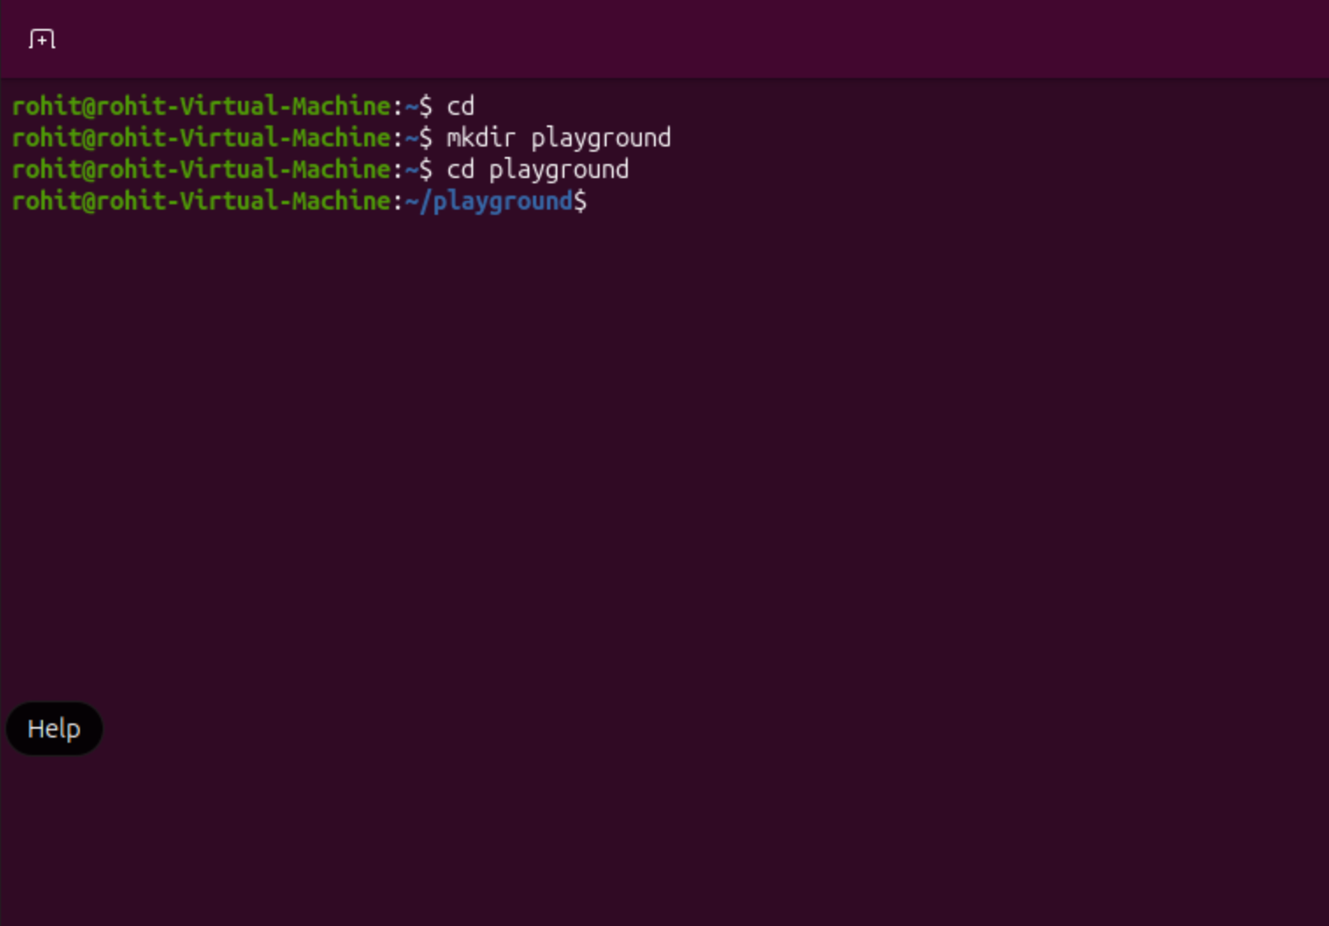

Cd playground changed the root folder to the /playground folder.

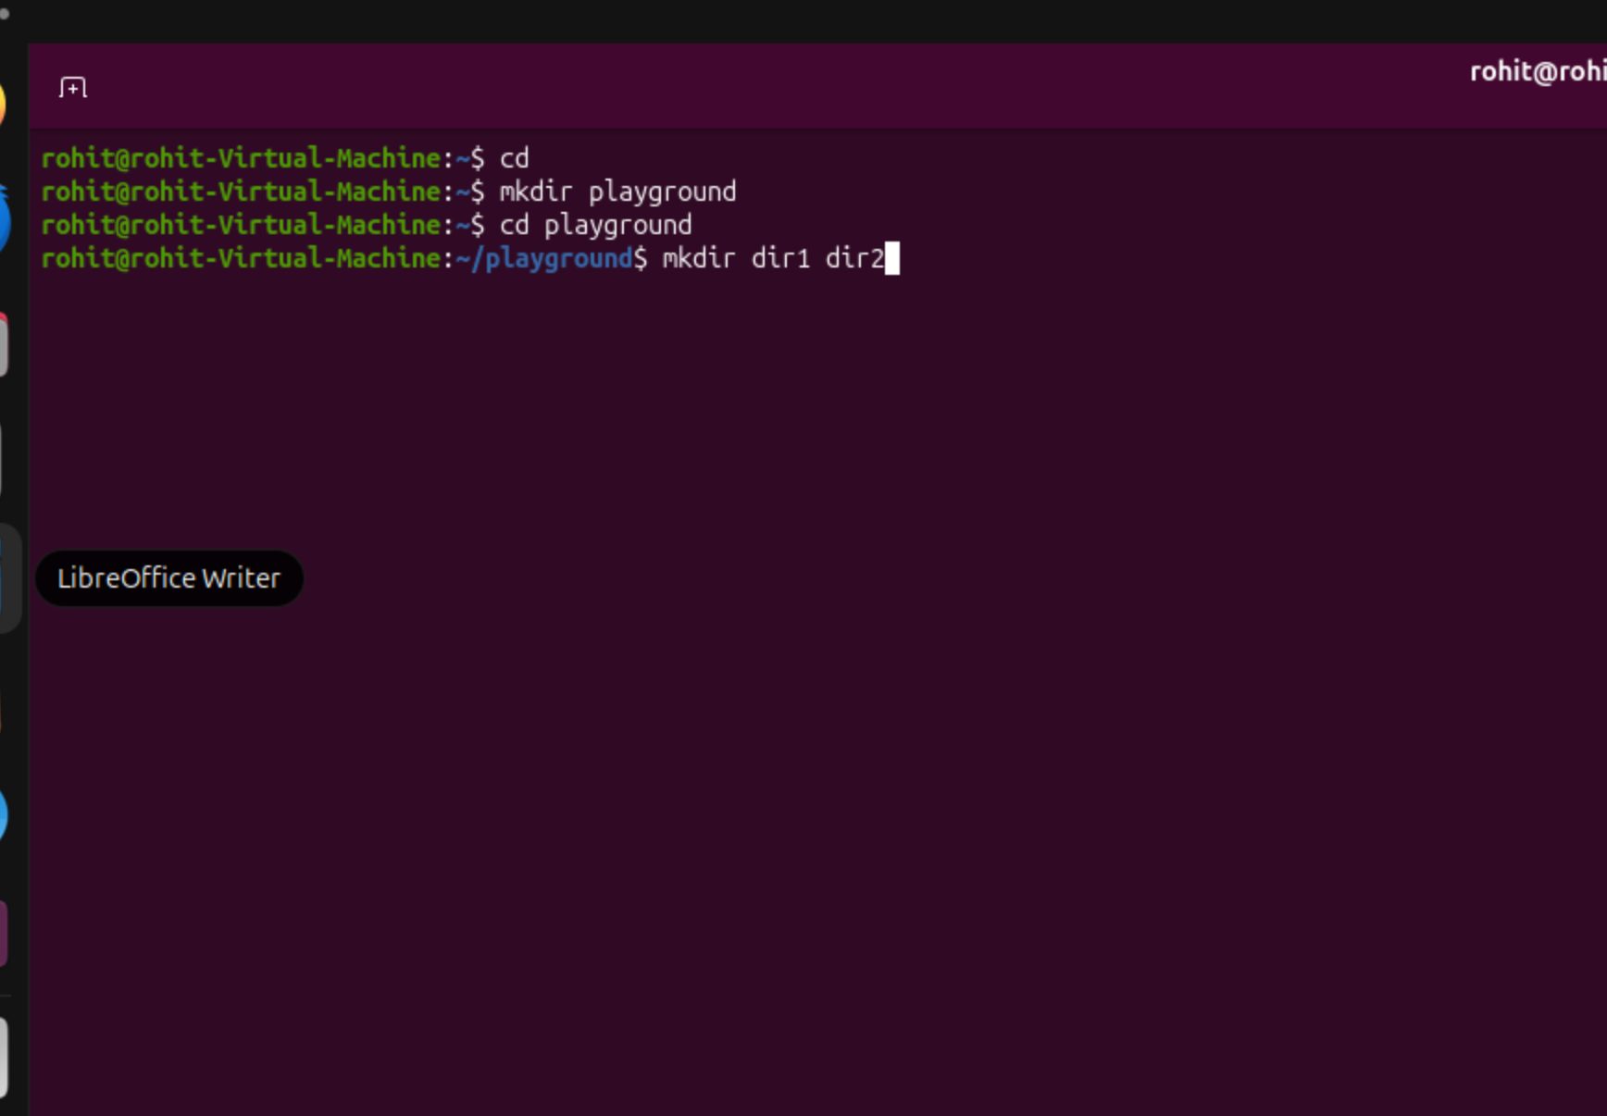
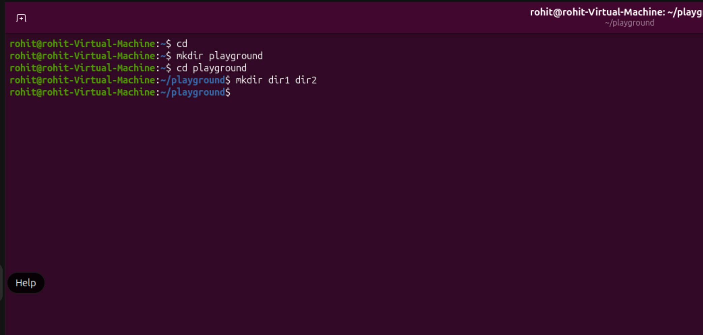
Mkdir dir1 dir2 did not produce any output on screen; it did however, create 2 folders called dir1 and dir2.

- 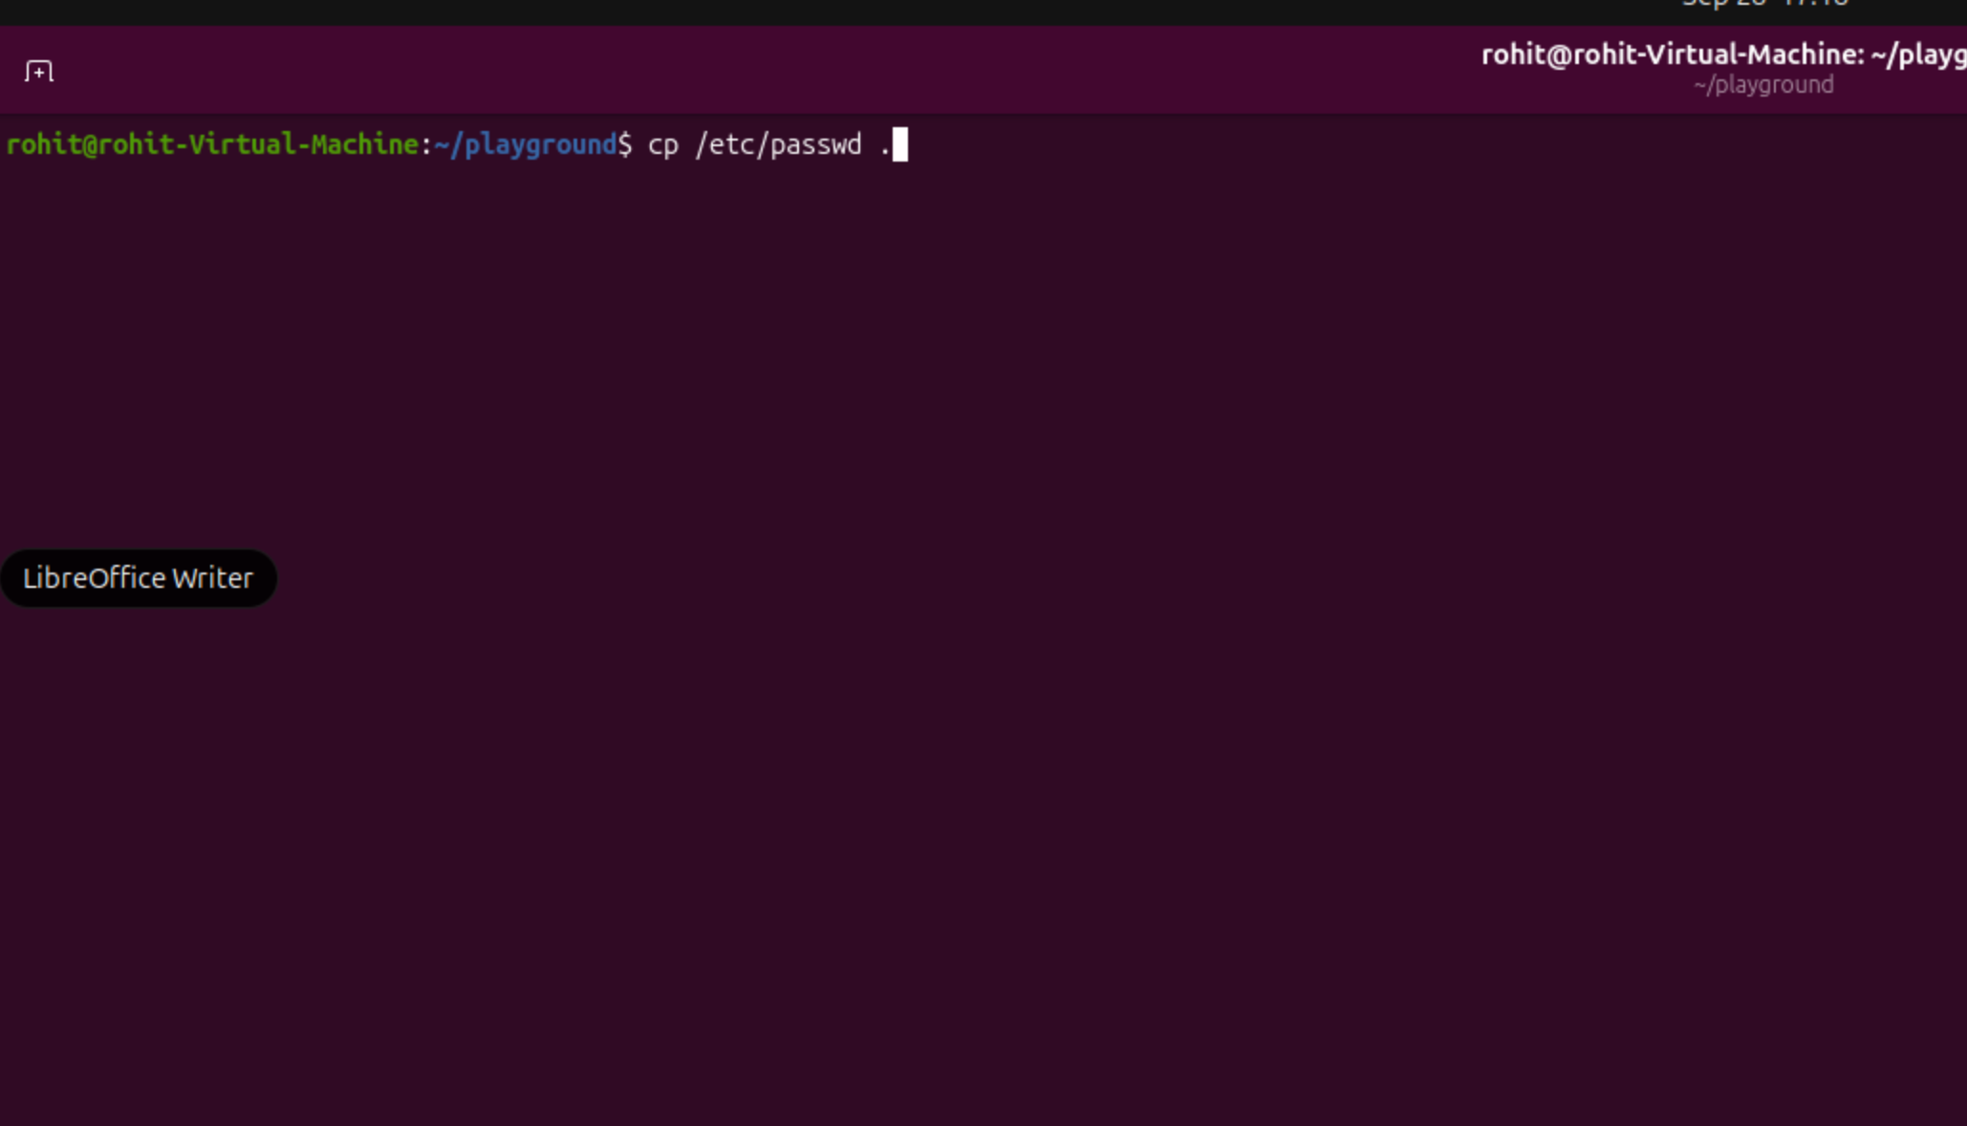
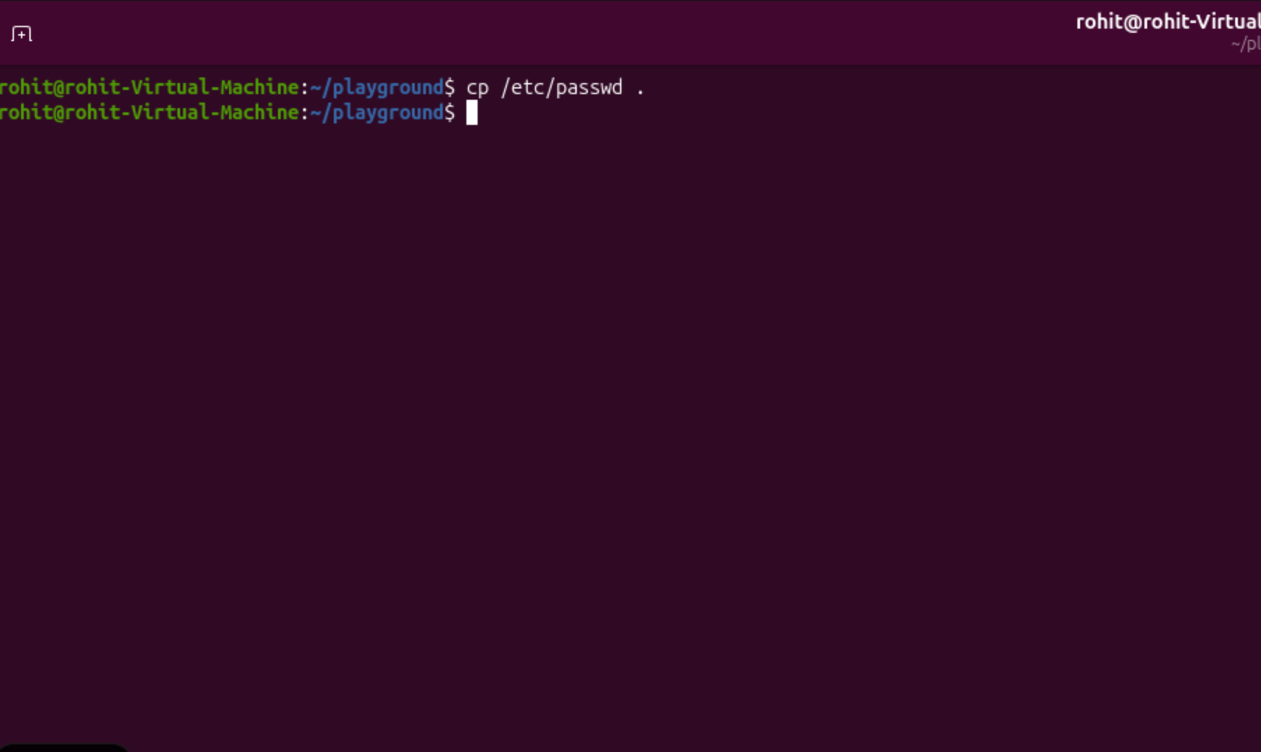

cp /etc/passwd . did not produce any output on screen, but it did copy the passwd file to the /playground directory.

- 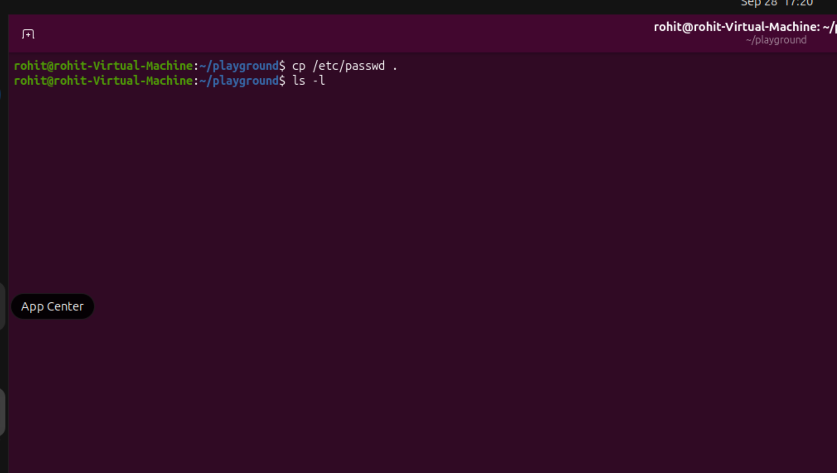
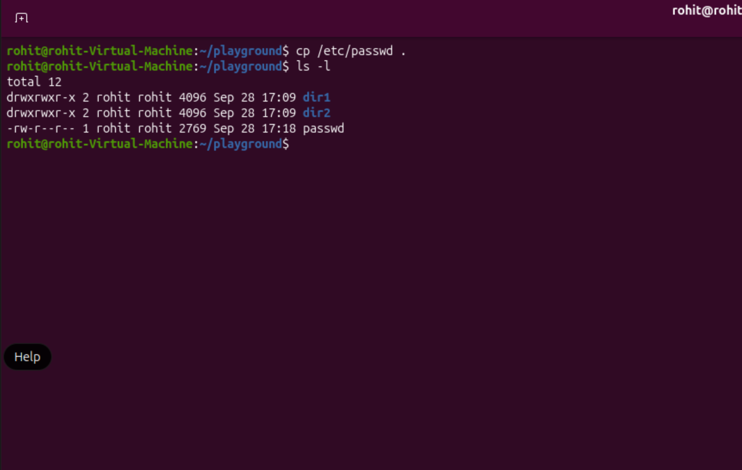

ls -l showed all the files in the current directory, including dir1, dir2, and the passwd file.

- 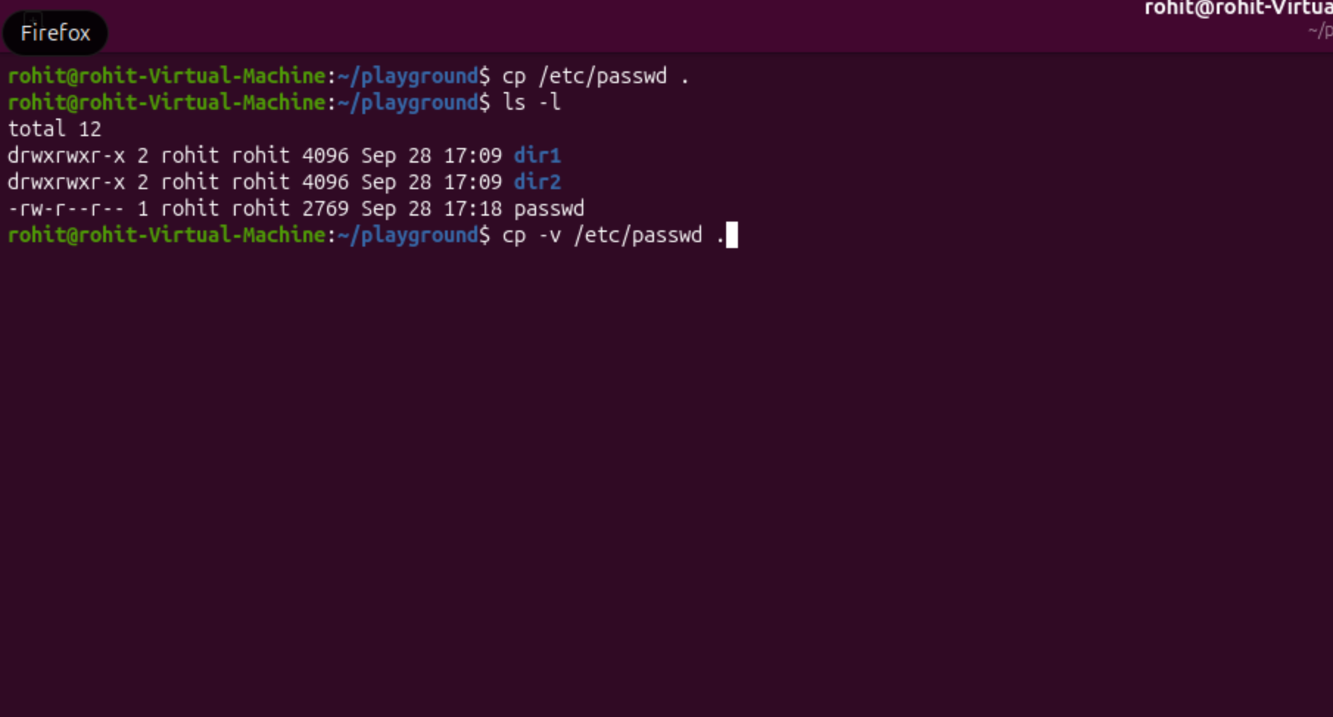
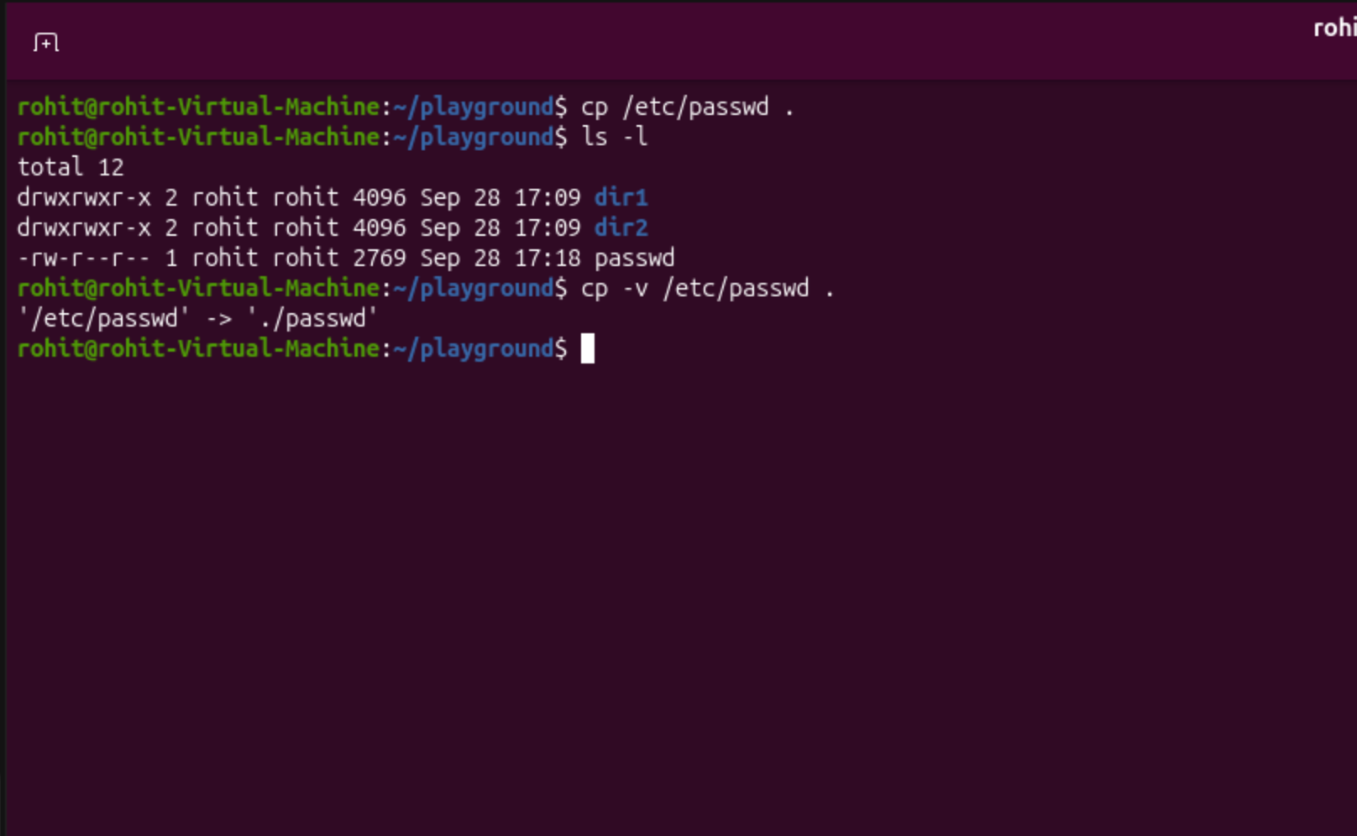

Cp -v /etc/passwd copied and overwrote the passwd file to the playground directory.

- 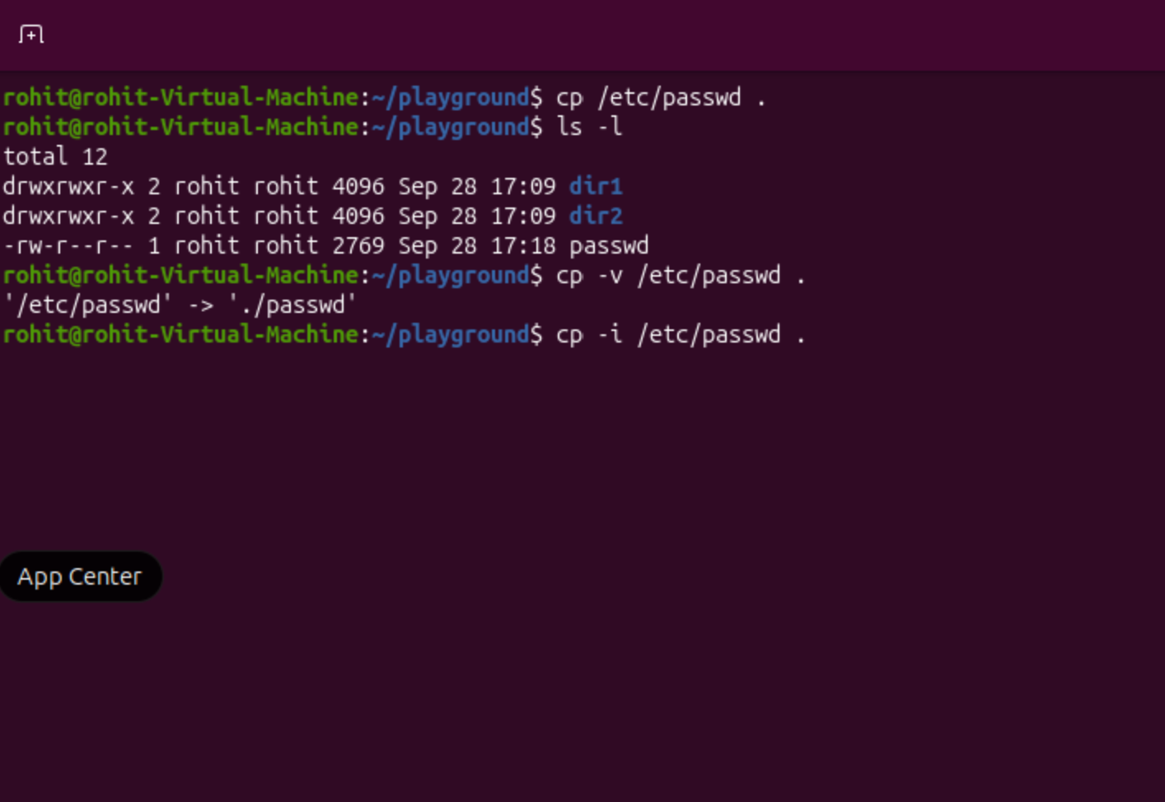
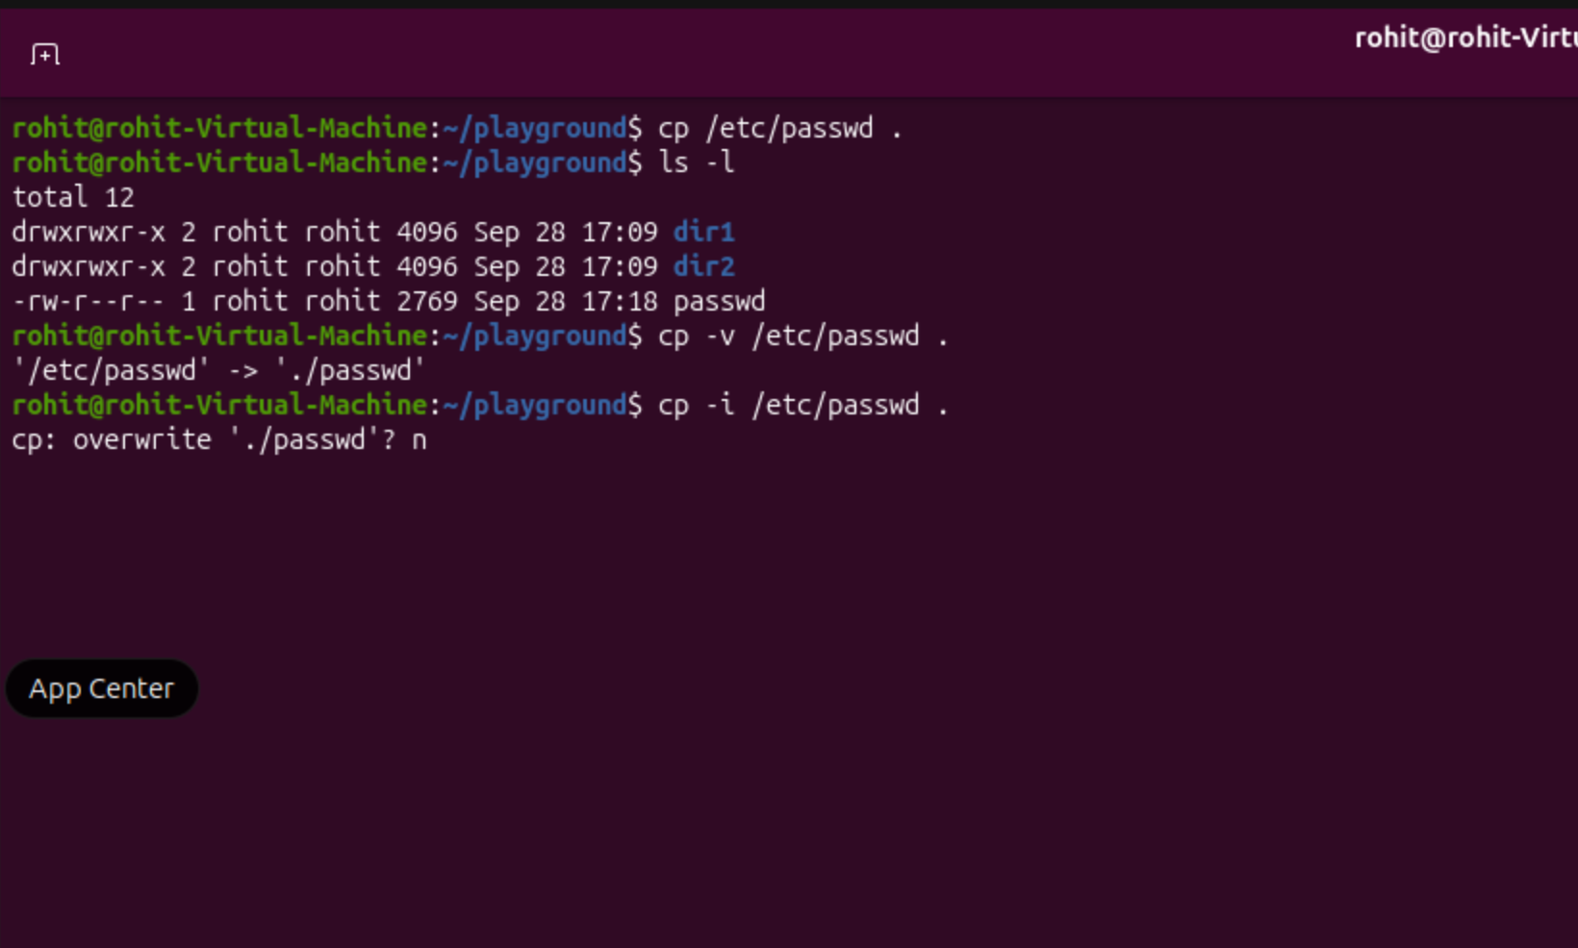
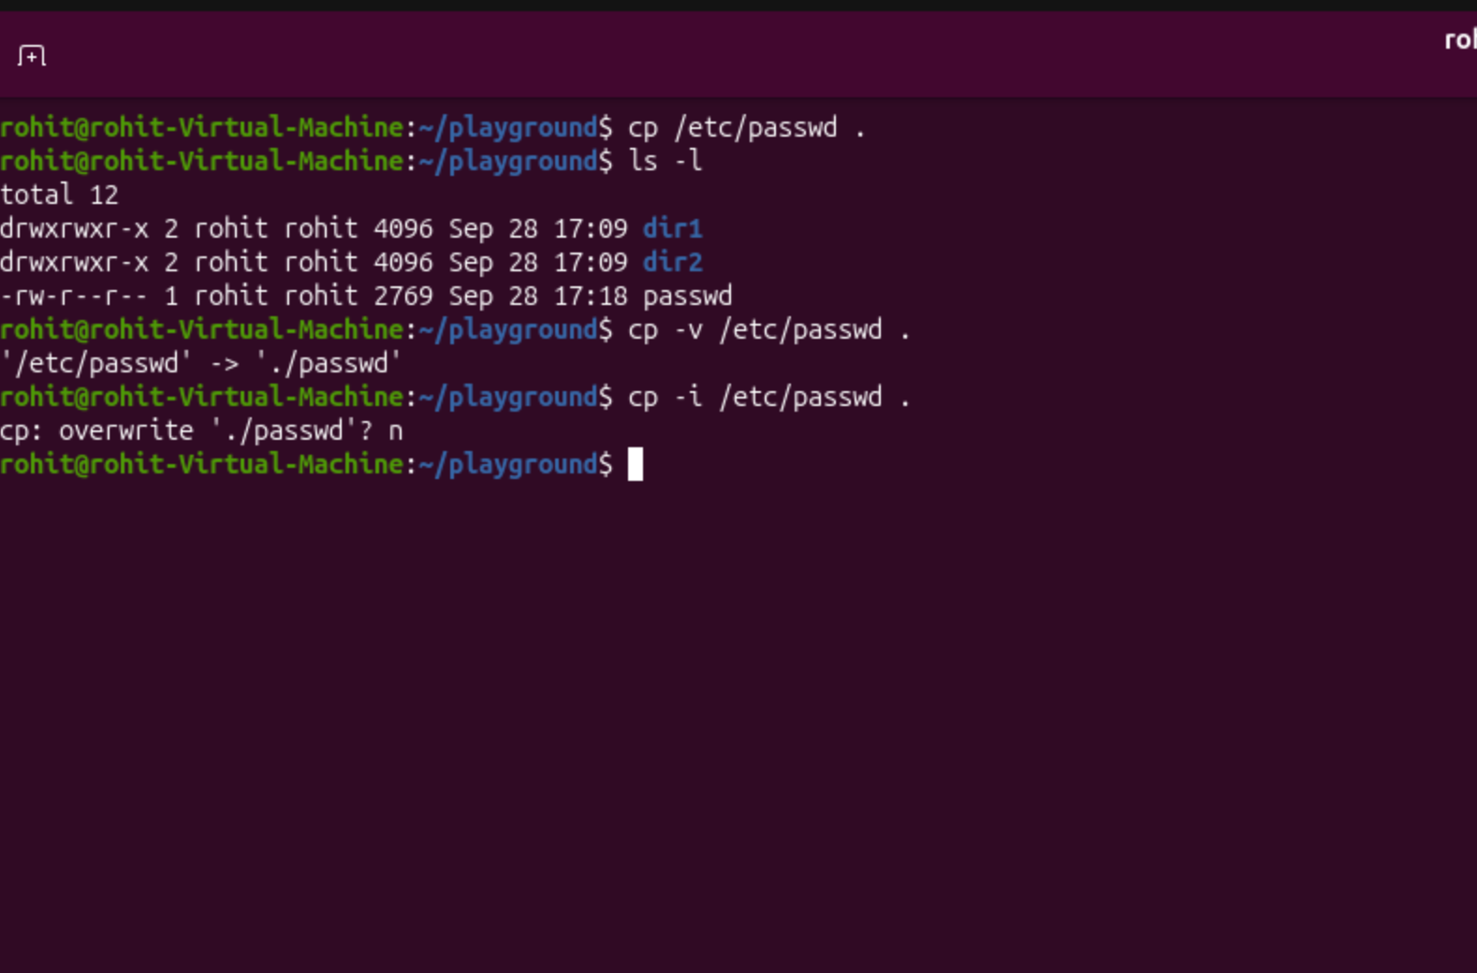

The cp -I command asked us for confirmation before overwriting the passwd file.

- 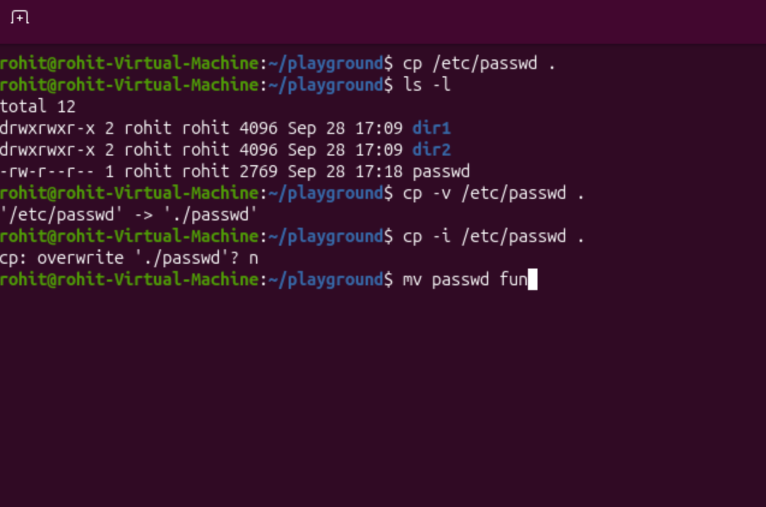
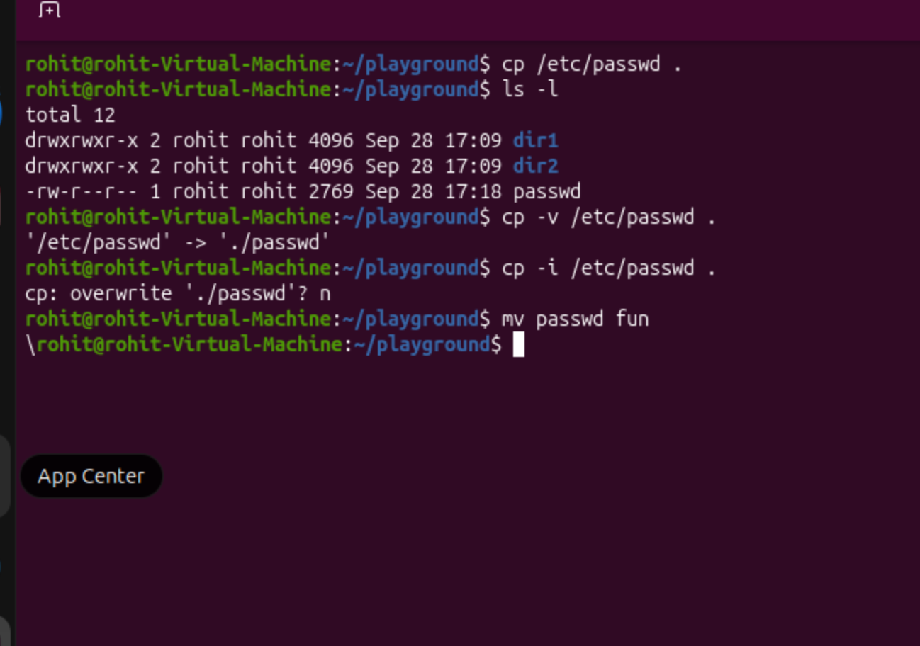
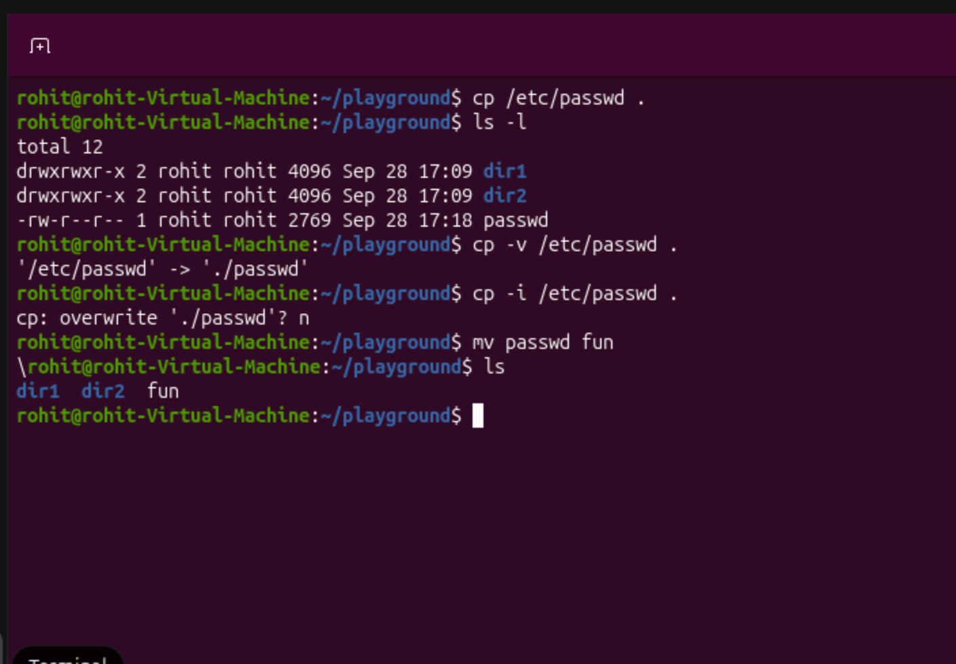

Mv passwd fun changed the name of the file ‘passwd’ to ‘fun’.

- 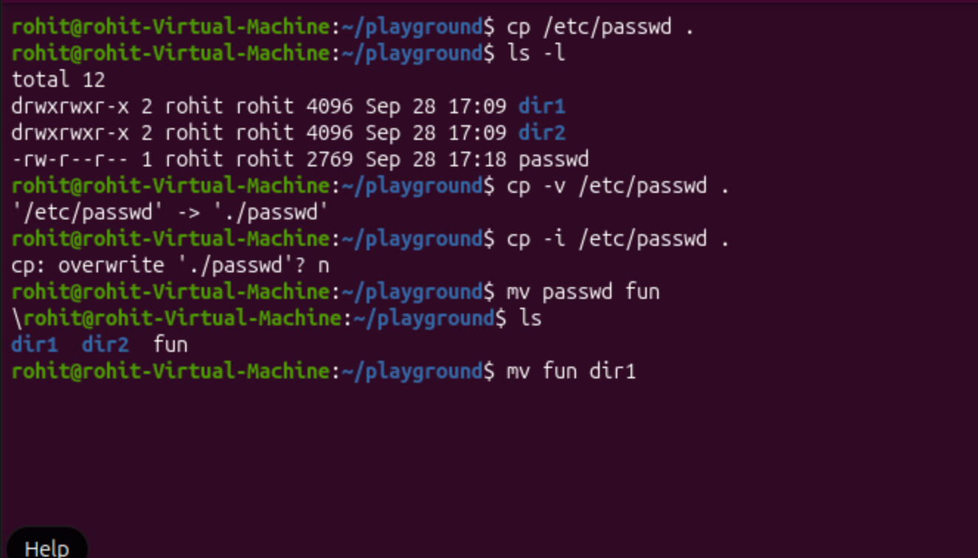

Mv fun dir1 moved the file ‘fun’ into the folder dir1.

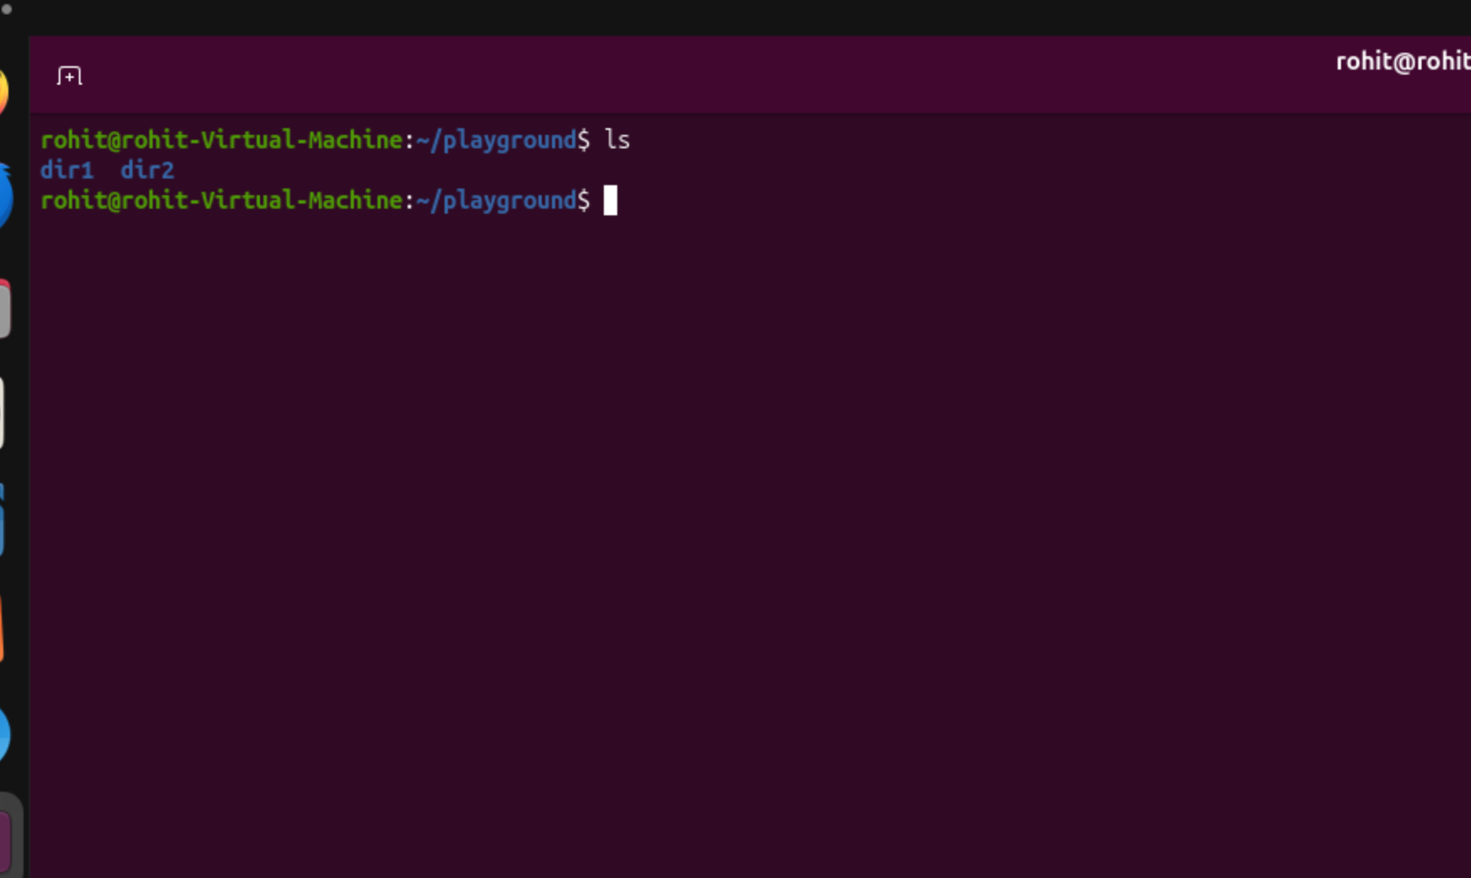

The file ‘fun’ is not here anymore; it has moved to dir1.

- 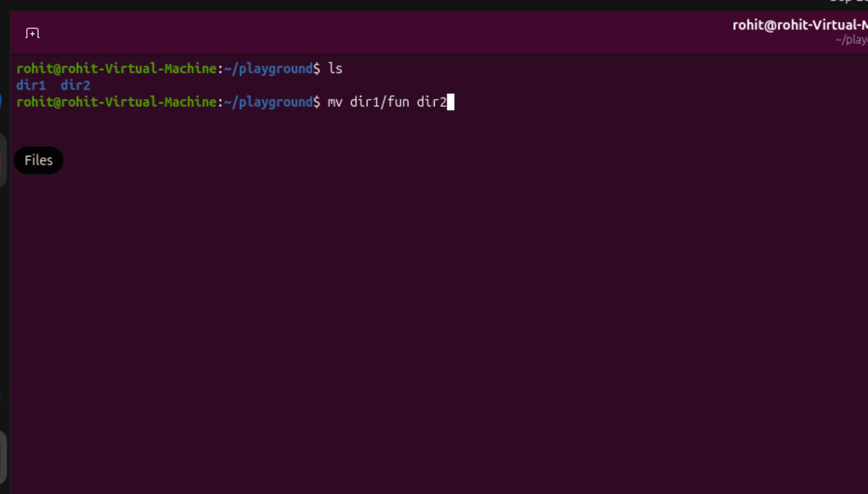
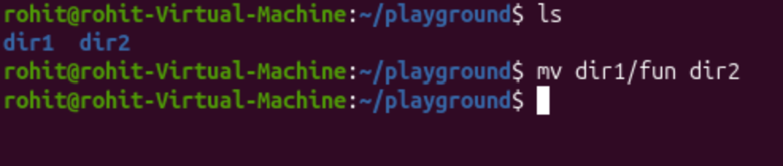
Mv dir1/fun dir2 moved the ‘fun’ file from the folder ‘dir1’ to ‘dir2’.

- 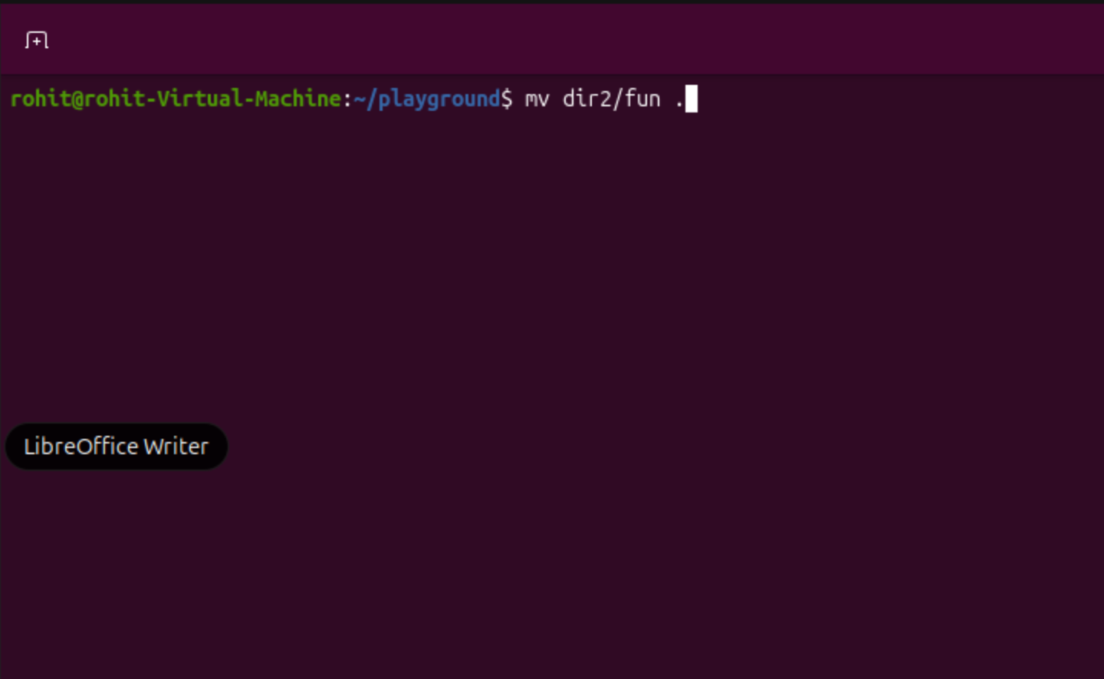
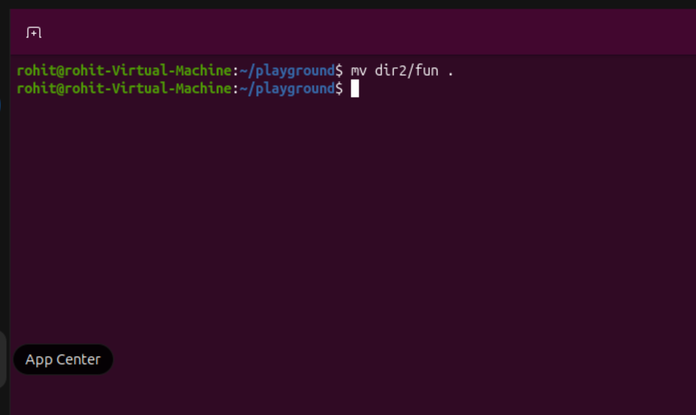

Mv dir2/fun . moved the ‘fun’ file back to the current directory.

- 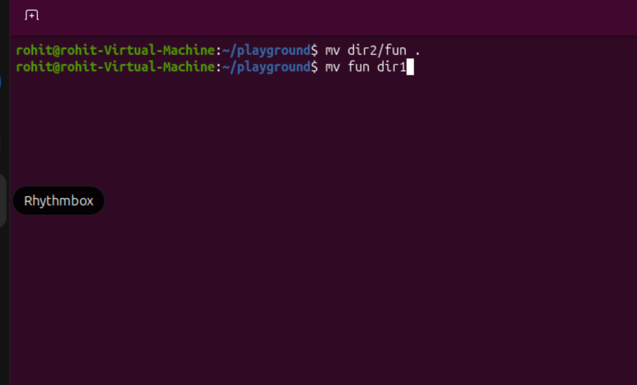
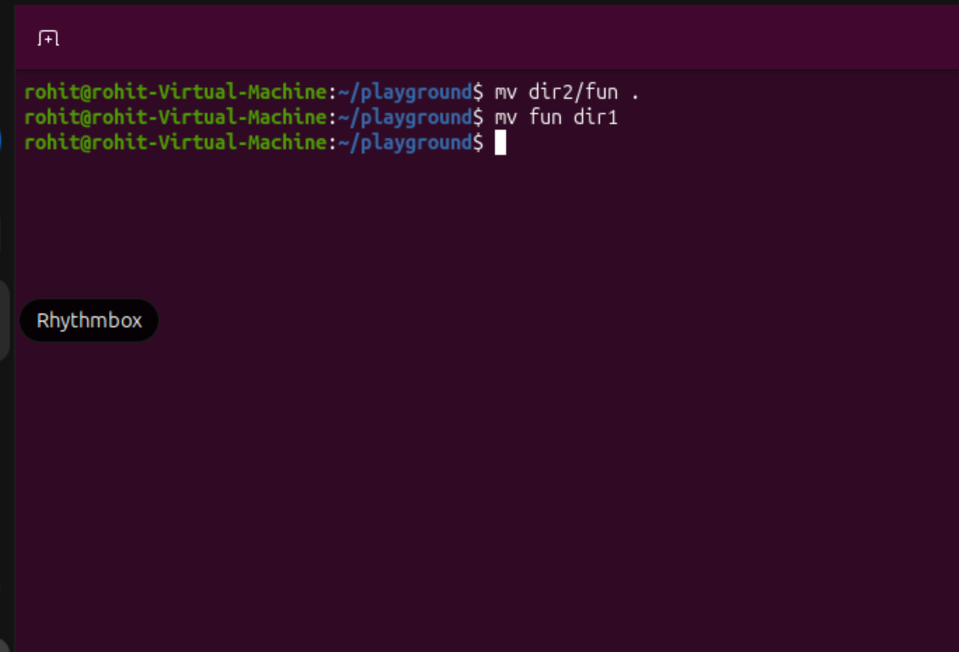

The ‘fun’ file was moved back to dir1.

- 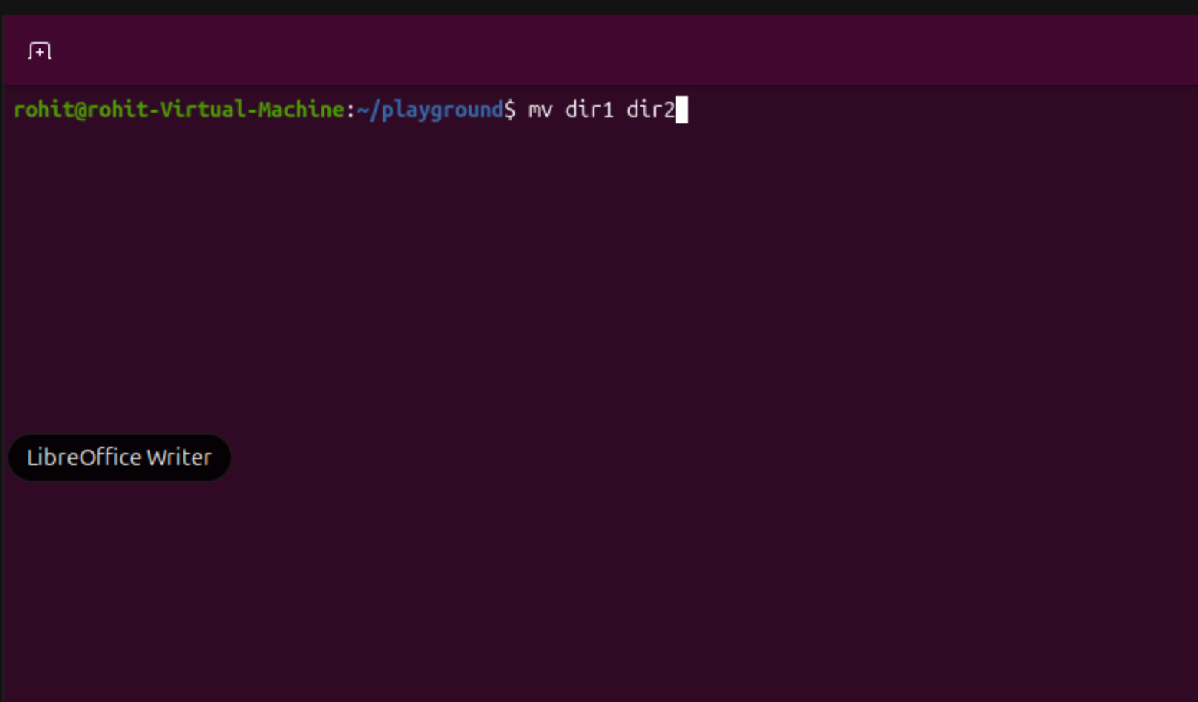
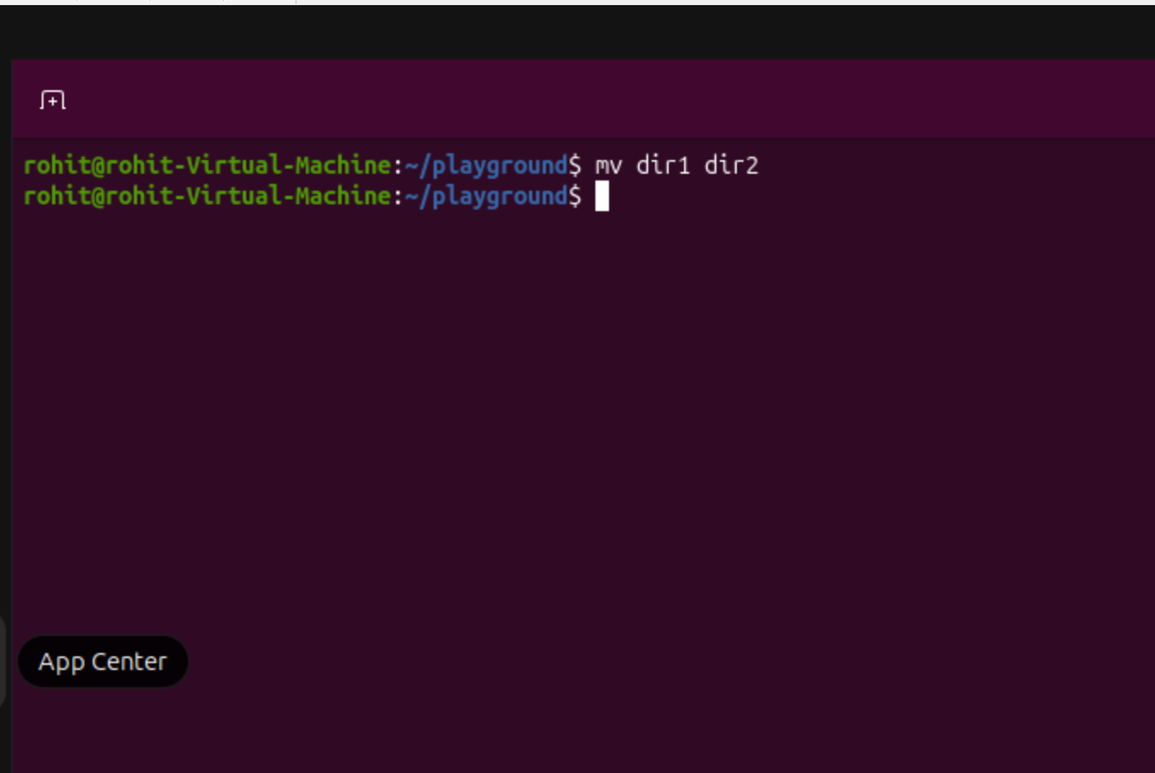

Mv dir1 dir2 moved the folder, ‘dir1’ into folder dir2.
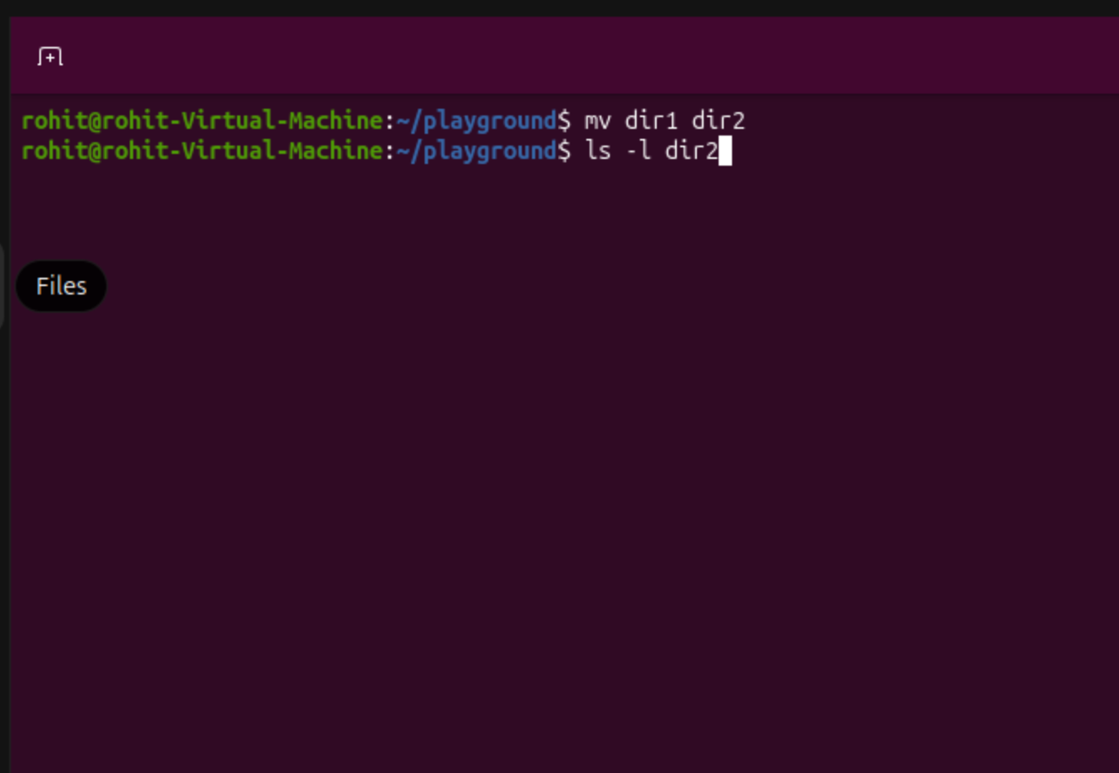
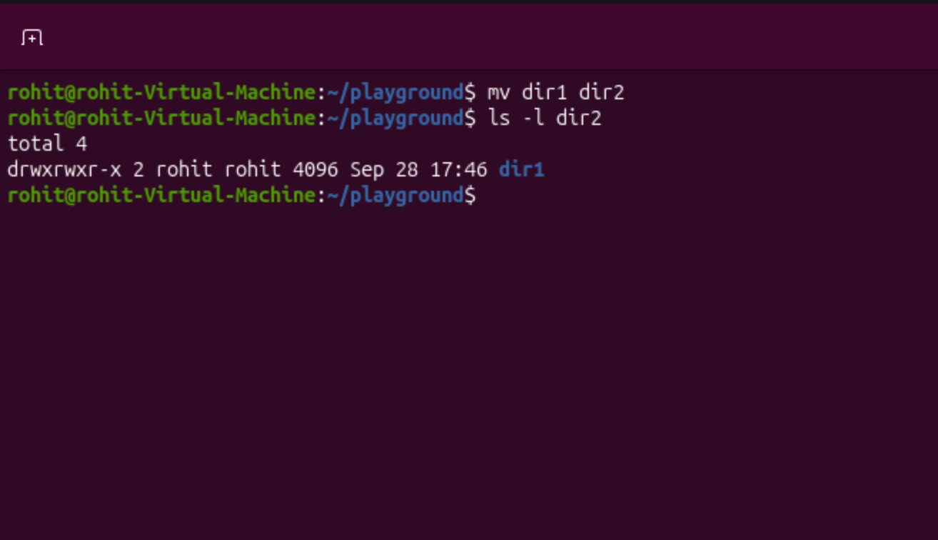

The ls -l dir2 command shows the contents of the folder dir2, which contains dir1.

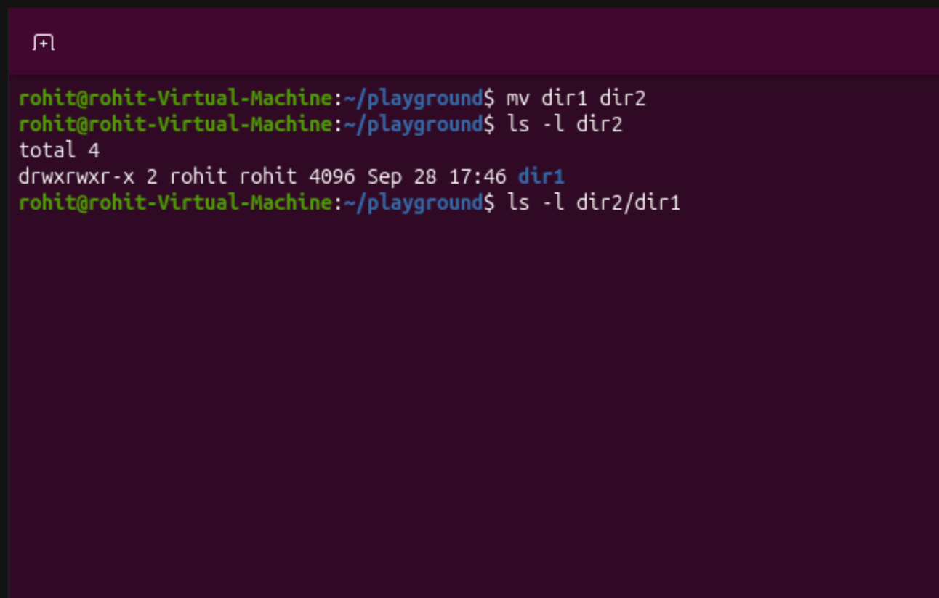
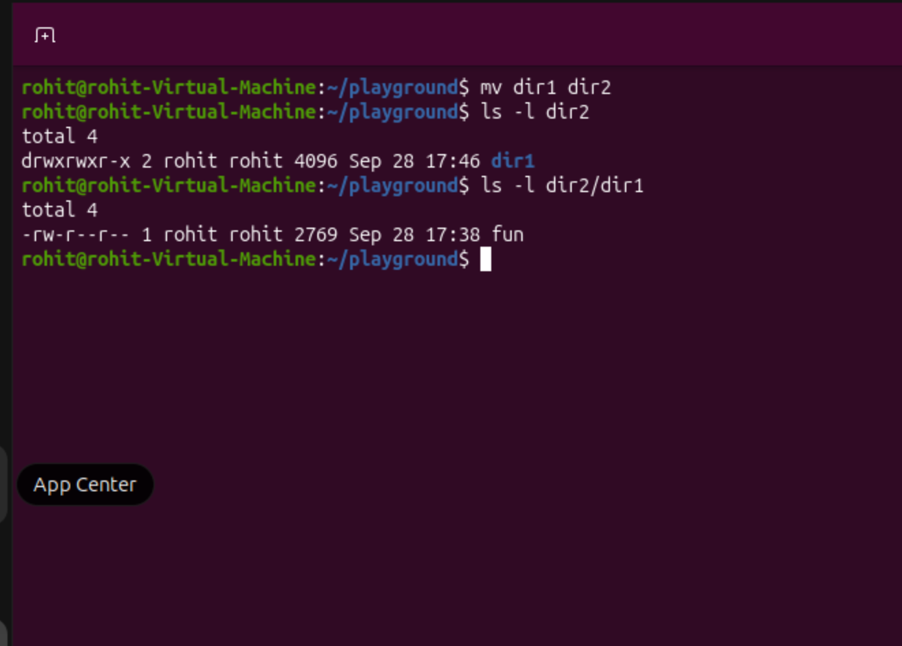

The ls -l dir2/dir1 command shows the contents of the dir1 folder, which contains the ‘fun’ text file.

- 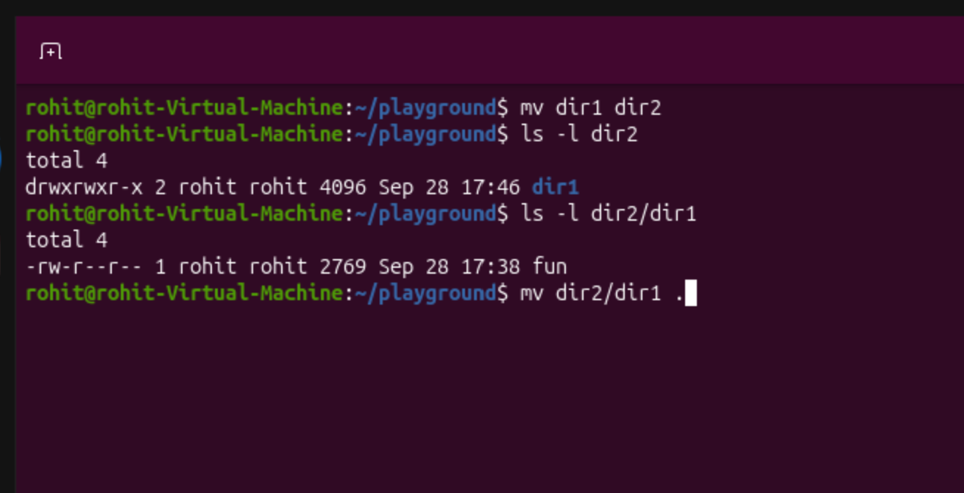
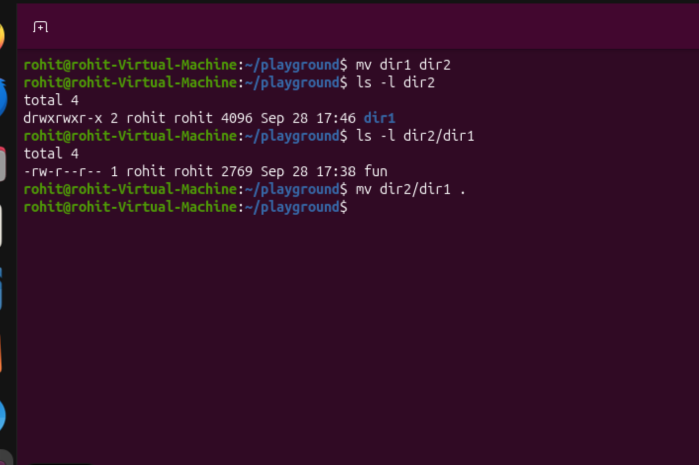

The mv dir2/dir1 . command moved the dir1 folder back into the root directory, which is /playground.

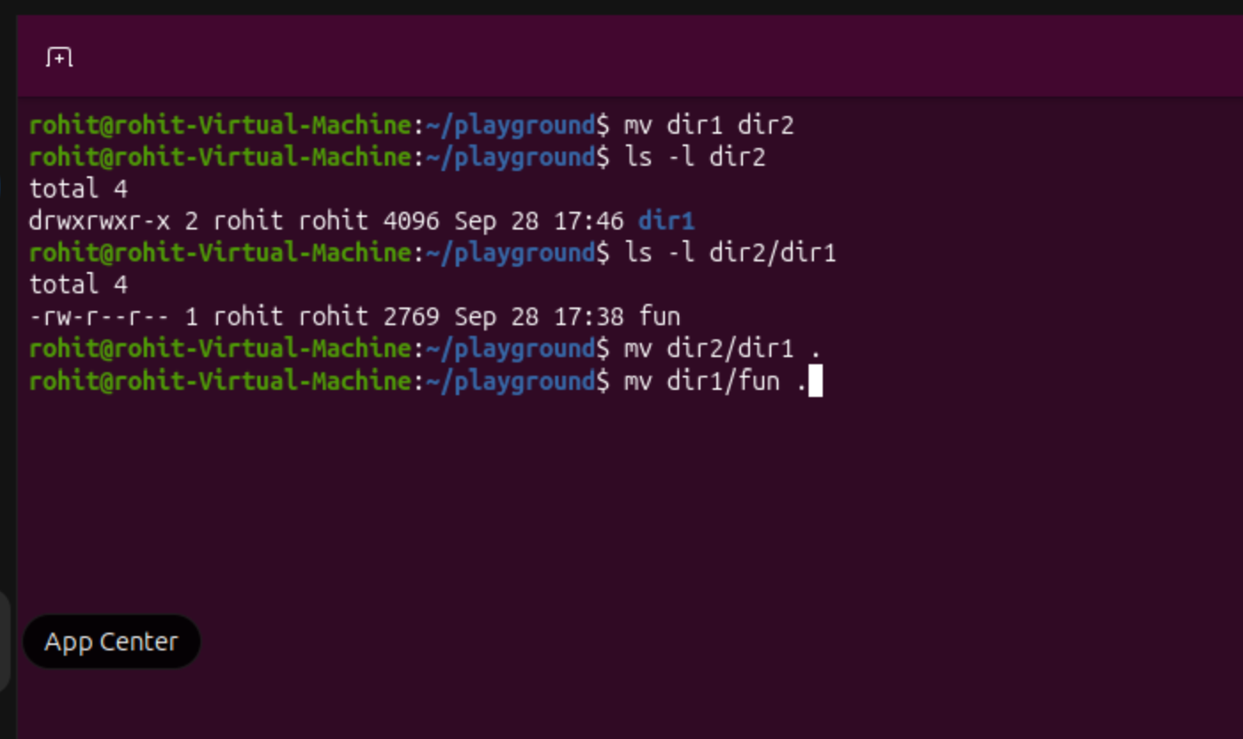
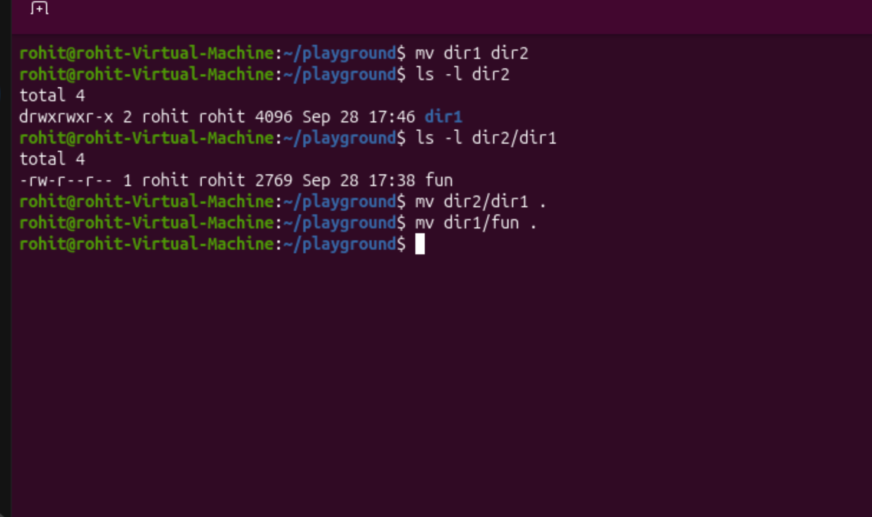
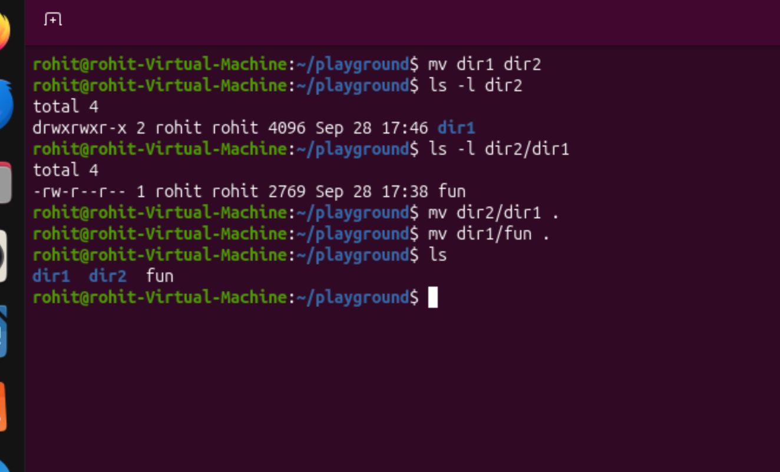

The mv dir1/fun . command moved the ‘fun’ file from dir1 back to the root directory, which is /playground.

